

Parallel & Distributed Computing

CSE525

Assignment **#5** - to be submitted to **Dr. Masroor Hussain**

**OpenMP based Barnes-Hut N-Body Simulation**

Submitted by,

**Quswar Mahmood Abid, CS2003**

OpenMP N-Body Simulation

# Coding and Assessing a simulation of N-Body based on Barnes-Hut Algorithm

In this assignment, we are required to simulate N-Body with Barnes Hut Algorithm. The coded implementation I have sourced is freely published by Raghav Pandya ([on GitHub](https://github.com/rpandya1990/Parallel-N-Body-Problem)) and provides parallel versions implemented in OpenGL, CUDA, and OpenMP alongside its serial implementation. Availability of implementation in different platforms and coding models with same data was the reason to select it. An edited fork of his repository is available at [this link](https://github.com/quswarabid/raghavpandya) [https://github.com/quswarabid/raghavpandya]

To get started, clone this repository, or use the file attached. To clone, execute this.

**$ git clone https://github.com/quswarabid/raghavpandya.git**

Navigate to **/2.openMp** for the parallelized version of serial code provided in **/1.serial** directory.

Execute ./a.out in both folders to run the file. To re-compile in case of any editions, execute:

**$ g++ -fopenmp n_body_omp.cpp**

Do not use **gcc** as it is a CPP file. This project uses six set of n-bodies to evaluate serial vs. parallel performances. These are 4, 120, 240, 480, 600, and 960 bodies, respectively. Input vectors are saved in **Nbody.h** file for position, velocity, acceleration, and mass. Code for benchmarking is included with in the file. Now we will run this simulation for 4 bodies and look at changes made in it. Then we will just run it with different number of bodies, just to benchmark.

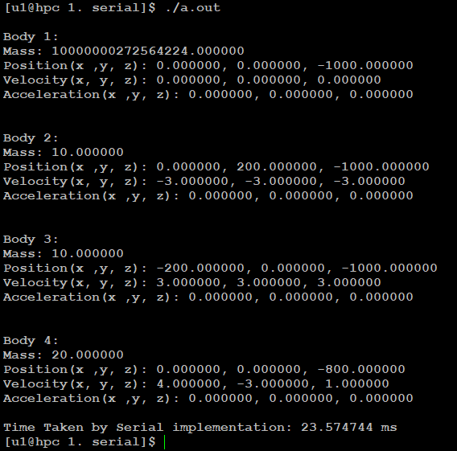

Figure . a simulation of 10,000 rounds with only 4 bodies

This simulation took 23.57 ms to complete. If we do not print the bodies, it takes a little less time, since printing on outstream also consumes time. Look at following results after using different number of bodies in serial.

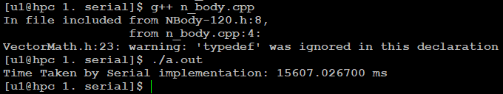

Figure . a serial simulation with 120 bodies

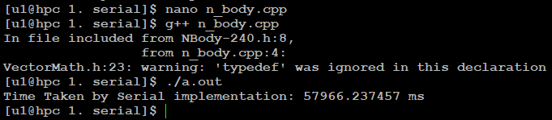

Figure . a serial simulation with 240 bodies

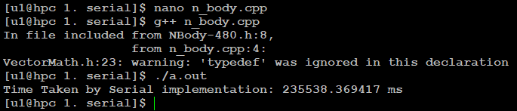

Figure . a serial simulation with 480 bodies

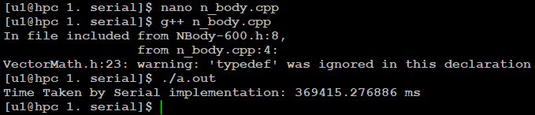

Figure . a serial simulation with 600 bodies

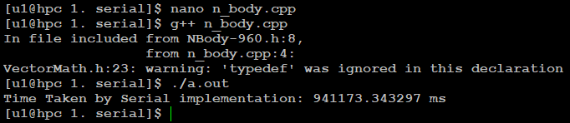

Figure . a serial simulation with 960 bodies

After we look how OpenMP based N-body simulation work, we will compare the two w.r.t. time.

|  |  |
| --- | --- |
| **Number of bodies** | **Time to simulate for 10,000 rounds (in ms)** |
| 4 | 23.574744 |
| 120 | 15,607.0267 |
| 240 | 57,966.237457 |
| 480 | 235,538.369417 |
| 600 | 369,415.276886 |
| 960 | 941,173.343297 |

Now let us take a look at how OpenMP based code perform.

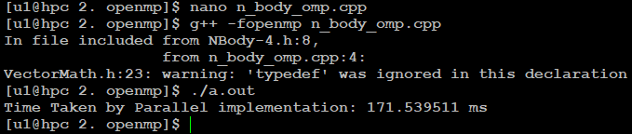

Figure . a parallel simulation with 4 bodies

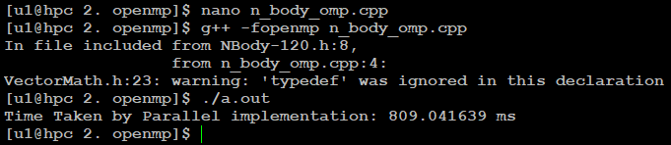

Figure . a parallel simulation with 120 bodies

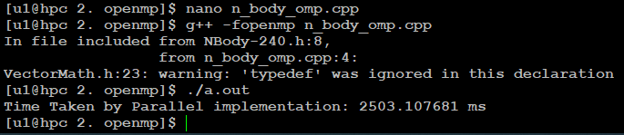

Figure . a parallel simulation with 240 bodies

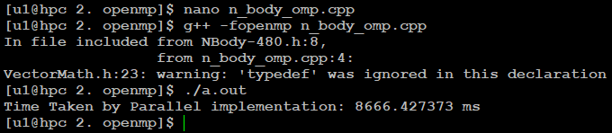

Figure . a parallel simulation with 480 bodies

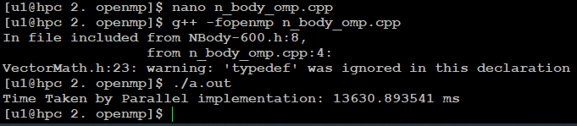

Figure . a parallel simulation with 600 bodies

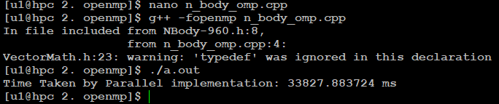

Figure . a parallel simulation with 960 bodies

Following table shows the how much time it took to simulate the N-bodies.

|  |  |
| --- | --- |
| **Number of bodies** | **Time to simulate for 10,000 rounds (in ms)** |
| 4 | 171.539511 |
| 120 | 809.041639 |
| 240 | 2,503.107681 |
| 480 | 8,666.427373 |
| 600 | 13,630.893541 |
| 960 | 33,827.883724 |

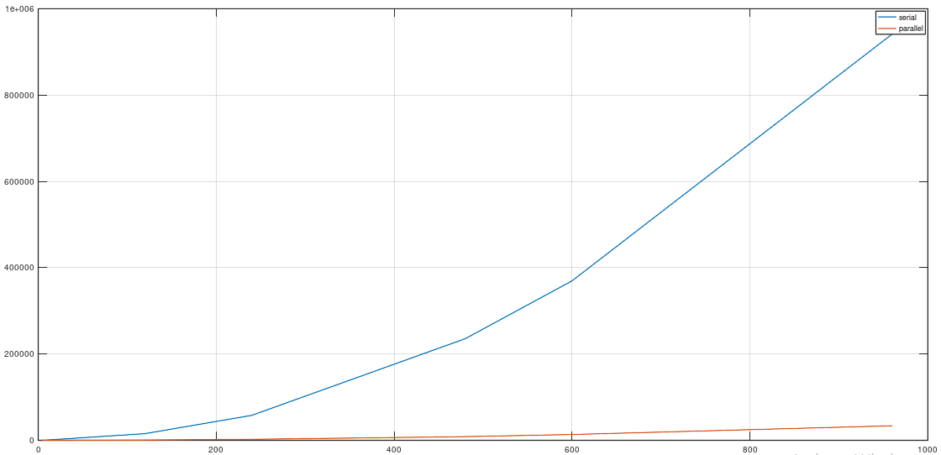

Figure . a comparison b/w serial and parallel implementation of N-body Simulation